Chapter 3 Outline:

Research Question: Does reduced data availability for overfished stocks impact the ability to detect rebuilding progress?

Rockfish

*Data*

* Single fishery active over 50 years
  + 1st Assessment in year 50 where the stock is overfished with a 10% depletion relative to virgin biomass
  + Historical data (*sample sizes were roughly based on sample sizes for yelloweye rockfish*)
    - Fishery
      * Catch known without error for all years
      * Length data for years 36-50 with 75 samples per year
      * Age Data for years 36-50 with 25 samples per year
    - Survey
      * Index for years 36-50 with CV = 0.50
      * Length data for years 36-50 with 10 samples per year
      * Age data for years 36-50 with 10 samples per year
  + Data Scenarios
    - The “base” scenario has no change in the fishery data (remain at historical sample level) when the stock is estimated to be overfished. The “alternative” scenario has reduced data availability for the fishery while the stock is estimated to be overfished. The changes to the fishery data are:
      * Fishery –
        + Composition data from the fishery is reduced while the stock is overfished to 15 lengths and 5 ages per year. When the stock is estimates to be rebuilt the sample sizes return to the historical data level.
    - Survey
      * No changes in the survey index or composition data levels while the stock is overfished.
  + Fishery Behavior
    - * + The selectivity curve shifts rightward while the stock is overfished. When the stock is estimated to be rebuilt the selectivity shifts back to the same historical selectivity (years 1-50)

This is mimicking a potential change in fishery behavior that an overfished declaration may induce. The selectivity could shift left or right given the life-history or behavior of the fishery. The right ward shift in selectivity was an arbitrary decision.

*Operating Model Complexity*

* Survey – high observation error CV = 0.50
  + Wanted to create a situation where the most informative data was being obtained from the fishery, so I chose to have a highly uncertain index from the survey with a low number of composition data samples.
* Process Error
  + Variable recruitment with sigma R = 0.60
    - I have explored autocorrelated recruitment, but they have not generally changed the simulation results, although the results have an increased estimated simulation interval.
  + Time-varying parameters
    - Natural mortality - lognormally distributed with 5% standard error.
      * Change this to an AR process in the operating model. What is the level of autocorrelation that I should incorporate???
      * I have explored scenarios where natural mortality is fixed and scenarios where it is varies annually. This does not change the general results.
        + I may want to change the error distribution for this parameter
    - Fishery Selectivity – The peak selectivity parameter varies annually about the mean value and is normally distributed with 5% standard error
      * Introducing annual variation fishery selectivity does result in a biased estimated of the peak selectivity parameter from the estimation method (the estimation method does not estimate annual variations).

*Estimation Method*

* R0, annual recruitment deviations, M, Lmin, Lmax, k, select survey and fishery selectivity parameters are estimated.
* If the stock is estimated overfished, the next assessment applies a time-block to allow for estimation of the shifted fishery peak selectivity parameter. The block is ended when the stock is estimated rebuilt.
* The operating model time-varying parameters are estimated as a single parameter in the estimation method for the entire period of the fishery (except the time-block allowed for the shift in selectivity).
* Catch during rebuilding is estimated based on 75% of SPR proxy and when rebuilt to the target stock size the catch is then estimated based on the SPR proxy.

Example Results:

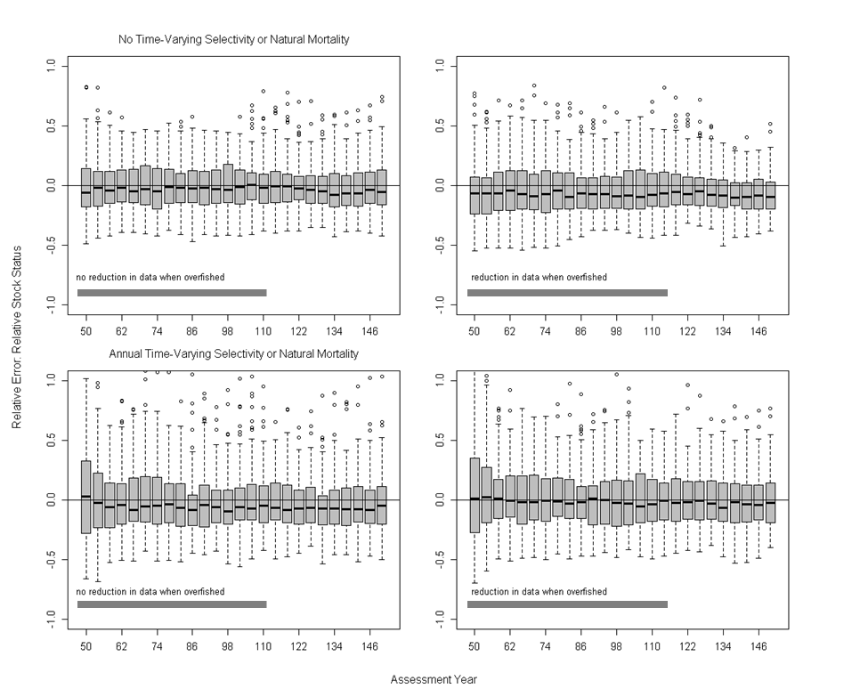

The top panels are the scenarios that do not incorporate annual variation in natural mortality of the peak selectivity parameter in the fishery (all scenarios apply the shift in selectivity), while the bottom row panels are scenarios that do include annual variation in those two parameters. The left side plots are reference scenarios that do not have any reduction in data from the fishery during rebuilding while those on the right do have the limited data coming from the fishery during rebuilding. The grey bars indicate the 80% simulation interval for the time that the stocks are rebuilding (e.g. the period of data restriction).

The results about relative error for the estimated stock status show me that there does seem to be a minimal impact of the reduced data when annual variation in parameters is not included (top row). However, when there is annual variation included (bottom row) the scenario with reduced data performs better presumably because the limited data is less informative on the shifts in the variable parameters resulting in estimates that do not vary greatly from year to year and tend to be similar to median parameter value (which matches the OM).

General Issue

The general results show little to no difference between the scenarios where data levels are reduced for the fishery during rebuilding compared to the ones which maintain fishery sample levels. Additionally, the estimates have a greater bias for the scenario when there are data levels when the operating model has time-varying parameters.

1. Go all the way – no fishery and survey data *(but time-varying M and selex)
   1. No data after the 1st assessment in year 50? Does this include the index of abundance? This may be a simulation that could evaluate the impact of the historical data versus the data during the rebuilding period.
2. You have to consider errors in steepness – estimating rec_devs helps get over this but how much
   1. How should this be done? I would hesitate to estimate M and h in tandem. Currently, steepness is fixed at its true value in the estimation model. Steepness is driving the rate of rebuilding which is the key point here, so perhaps I should be estimating steepness and not natural mortality. However, would it be reasonable to attempt to estimate steepness in the first assessment when the model has only had a one-way trip decline in abundance. I could see estimating steepness in the subsequent assessments because there should be information for this parameter.
3. What about a case in which the survey selex changes because the survey is not allowed into certain areas.
   1. I think this is a secondary issue. One of the key points for this study is that the survey does not sample the simulated stock well and hence is not a good source of information on stock status.